# "How to Improve Your E-commerce Website for Better Sales

A well-designed **e-commerce website** is key to attracting and keeping customers. It's vital to focus on **sales strategies** that improve the user experience. A good e-commerce site has a user-friendly interface, easy navigation, and product descriptions that highlight products well.

To boost sales and stay competitive, optimizing your **e-commerce website** is crucial. Effective **sales strategies**, like a smooth checkout and using customer reviews, make shopping enjoyable. This encourages customers to come back and buy more, improving your website.

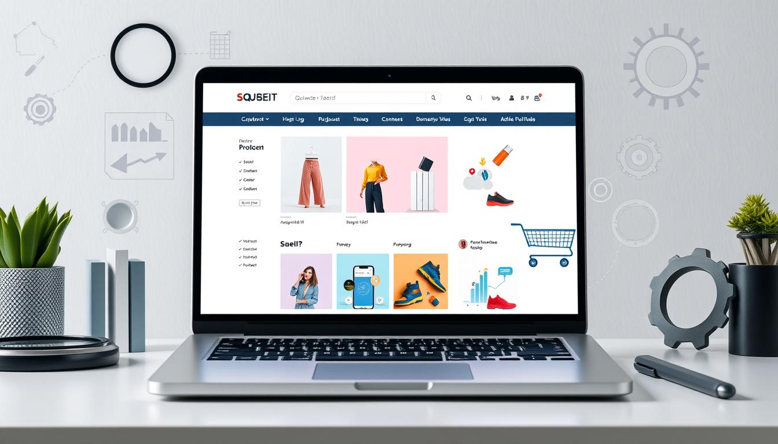

## Introduction to E-commerce Website Optimization

For businesses aiming to grow online and boost sales, a well-optimized **e-commerce website** is essential. By focusing on design, navigation, and product descriptions, you can make a site that drives sales and growth.

### Key Takeaways

* Optimize your e-commerce website for a seamless user experience
* Implement effective **sales strategies** to drive conversions
* Streamline the checkout process to reduce cart abandonment
* Leverage customer reviews and social proof to build trust
* Focus on creating compelling product descriptions that sell
* Use data and analytics to inform e-commerce website optimization decisions

## Understanding E-commerce Website Fundamentals

Creating a successful e-commerce website involves several key components. A well-designed site can attract and keep customers. It's a platform for customers to browse and buy products online. It must be secure, reliable, and easy to use.

An e-commerce website should be easy for customers to navigate. This can be done with clear product descriptions, high-quality images, and a simple checkout. Understanding these basics helps business owners improve their online stores.

### Key Components of Successful Online Stores

Some key components of successful online stores include:

* A secure payment gateway
* A user-friendly interface
* High-quality product images
* Clear and concise product descriptions
* A simple checkout process

By adding these components, business owners can make their e-commerce websites functional and effective. The website should be designed with the customer in mind, offering a smooth and enjoyable shopping experience.

https://www.youtube.com/watch?v=JzAbA4wgLyw

### Essential E-commerce Features

There are also essential e-commerce features that can improve the shopping experience. These include product reviews, customer testimonials, and social media integration. Adding these features can help build trust with customers and increase sales.

## Optimizing Your Product Page Design for Maximum Conversion

When it comes to *product page optimization*, several key elements are important. A well-designed product page can turn visitors into customers. Start with a clear and concise product description. It should highlight the product's features and benefits.

Here are some tips for effective **product page optimization**:

* Use high-quality product images from different angles.
* Make sure calls-to-action encourage visitors to buy.
* Include customer reviews and ratings to build trust.

By adding these elements, you can optimize your product page for better conversion. Keep your design clean and simple. This makes it easy for visitors to find what they need. With the right *product page optimization* strategy, you can boost sales and grow your business.

## product page optimizationCreating Compelling Product Descriptions That Sell

**Product page optimization** is key to driving sales. Often, the product description is overlooked. A well-written description can convince customers to buy.

Studies show that SEO-friendly product descriptions rank better in search engines. Search engines like content that's informative, engaging, and has the right keywords.

### Writing Persuasive Product Copy

To write persuasive copy, focus on the product's benefits and features. Use strong words and calls-to-action to urge customers to act fast.

### Incorporating SEO-Friendly Content

Adding SEO-friendly content to your descriptions boosts optimization. This includes using the right keywords, optimizing images, and creating engaging content.

https://www.youtube.com/watch?v=aYB1Uqs3n9E

### Using Power Words and Call-to-Actions

Power words and calls-to-action create urgency and push sales. Examples are "limited time offer" and "free shipping." Use "buy now" or "shop now" to act.

* Use relevant keywords in your product descriptions
* Optimize images to improve page load times
* Create high-quality, engaging content

Follow these tips to make your product descriptions sell. Keep your content engaging, informative, and keyword-rich. This will boost your sales strategies.

## Implementing Effective E-commerce Website Navigation

Navigation is key to a smooth user experience on an e-commerce site. A good navigation system can turn visitors into buyers. It's important to focus on menu structure, search, and category organization.

A website with easy navigation boosts the shopping experience. It leads to more engagement, less bounce rates, and more sales. Key points for navigation include:

* Simple and intuitive menu structures
* Robust search functionality with filters and sorting options
* Clear and organized category pages

By adding these features, sites become easier to use. This makes it more likely for customers to find what they need and buy. A well-navigated site can increase satisfaction, loyalty, and revenue.

Businesses can also use *breadcrumb navigation* to help customers track their path. *Responsive design* ensures navigation works on all devices, like desktops, tablets, and smartphones.

| Navigation Element | Best Practice |
| --- | --- |
| Menu Structure | Keep it simple and intuitive |
| Search Functionality | Include filters and sorting options |
| Category Pages | Organize products clearly and consistently |

## Enhancing Your Visual Content Strategy

To boost sales on your e-commerce site, a strong visual content plan is key. This means using top-notch product images, making engaging videos, and using smart visual merchandising. These steps help create a deeper experience for customers, encouraging them to buy more.

Visual content is vital for sales strategies. *Research has shown* that customers prefer products with great images and videos. Here are some ways to improve your visual content:

* Use high-quality product images that show the product from various angles
* Create engaging product videos that highlight the product's features and benefits
* Implement effective visual merchandising techniques, such as using lifestyle images and customer testimonials

By following these tips, you can enhance the shopping experience on your site and boost sales. 

Remember, a well-thought-out visual content strategy is essential for sales and revenue on your e-commerce site. By focusing on creating high-quality visual content, you can help your business succeed and stay competitive.

A well-designed visual content strategy can increase sales by up to 20% and improve customer engagement by up to 30%.

## Streamlining the Checkout Process

To boost sales on an e-commerce site, making checkout easy is key. A hard or long checkout can make people leave without buying. By using smart sales tactics, businesses can keep more customers and make buying smooth.

Some ways to make checkout better include cutting down steps, letting guests buy without signing up, and adding easy payment options. These steps help make buying easier and faster, leading to more sales.

### Reducing Cart Abandonment

Cart abandonment is a big problem, with about 70% of carts left behind. To fight this, businesses can send reminders, offer deals, and make checkout simple. By doing this, they can keep more customers and make more money.

### Payment Gateway Integration

Adding different payment options is vital for checkout. It lets customers pay in many ways, making buying easier. This can cut down on cart abandonment and boost sales.

https://www.youtube.com/watch?v=U61nnFPLTsk

### Guest Checkout Options

Guest checkout makes buying easier and can lower cart abandonment. It lets people buy without signing up, which is convenient. Options like PayPal and Amazon Pay are popular for this.

* Streamline the checkout process to reduce cart abandonment
* Offer guest checkout options to make the process more convenient
* Integrate multiple payment gateways to offer customers a range of payment options

By using these strategies, businesses can make checkout smooth and efficient. This leads to more sales and helps them stay ahead in the online market.

## Mobile Optimization Strategies for E-commerce Success

Having a mobile-friendly e-commerce website is key for boosting sales and revenue. Most online shoppers use their mobile devices to shop. So, it's vital to make your website easy to use on smaller screens.

Effective strategies include *streamlining your website's design*, *optimizing product pages* for mobile, and *implementing mobile payment options*. These steps can enhance user experience, boost conversions, and increase sales. Here are some tips to improve your website's mobile optimization:

* Use a responsive design that adapts to different screen sizes and devices
* Optimize images to reduce load times and improve page speed
* Implement a mobile-friendly payment gateway to simplify the checkout process

By using these strategies, you can make your e-commerce website better. This will help your sales strategies work even better. Always test and optimize your website to give the best experience to your mobile visitors.

## Leveraging Customer Reviews and Social Proof

To boost sales on your e-commerce site, building trust is key. Customer reviews and social proof are great tools for this. They help turn visitors into buyers by showing positive feedback.

There are many ways to get reviews. You can email customers after they buy, offer discounts for reviews, or make it simple to leave feedback on your site. Some sites even use third-party services for reviews.

### Effective Review Collection Methods

* Send follow-up emails to customers after a purchase
* Offer incentives for leaving reviews, such as discounts or free shipping
* Make it easy for customers to leave feedback on your website

It's important to display testimonials well. Use customer quotes on your homepage or product pages. This builds trust and credibility, making your sales strategies more effective. By using customer reviews and social proof, your e-commerce site becomes more persuasive and trustworthy, leading to more sales.

## Conclusion: Taking Your E-commerce Website to the Next Level

As we wrap up this guide, the secret to boosting your e-commerce site is simple: keep optimizing and innovating. By using the strategies we've shared, you can make your online store engaging and easy to use. This will draw in new customers and keep them coming back for more.

Don't forget, the tips on optimizing product pages and focusing on customers are key to success. Keep improving your site, try out new things, and listen to what your customers want. This will help you stay ahead in the market.

With a solid grasp of e-commerce basics, a great design, and a smooth checkout process, your store will attract and keep loyal customers. Use social proof, data, and always aim to improve the user experience.

By elevating your e-commerce site, you set your business up for lasting growth. You'll strengthen your brand and boost sales. Start this journey with confidence, and watch your online store flourish for your audience.

## FAQ

### How can I optimize my product pages to increase sales?

To boost sales, make your product pages engaging. Use clear descriptions and high-quality images. Add calls-to-action to guide customers. Make sure your site is easy to use and offers a smooth shopping experience.

### What are the essential e-commerce features I should have on my website?

Your site needs to be secure and easy to navigate. It should have a simple checkout process and a reliable search function. These features help customers feel comfortable and increase the chance of them buying.

### How can I create product descriptions that sell?

Write descriptions that grab attention and are easy to find online. Use words that motivate and include clear calls-to-action. Highlight what makes your product special and how it meets your customers' needs.

### What are the best practices for implementing effective e-commerce website navigation?

Keep your menu simple and your search function efficient. Organize products in a way that's easy for customers to find what they need. This makes shopping on your site a breeze and can lead to more sales.

### How can I enhance my visual content strategy to drive more sales?

Use top-notch images and videos to showcase your products. Make your content visually appealing and engaging. This can make your products more attractive to customers and boost sales.

### What strategies can I use to streamline the checkout process and reduce cart abandonment?

Make checkout easy by integrating secure payment options and offering guest checkout. A smooth checkout process can reduce cart abandonment and increase sales.

### How can I optimize my e-commerce website for mobile devices?

Ensure your site works well on mobile devices. Optimize product pages and payment options for smaller screens. A good mobile experience can turn more visitors into customers.

### How can I leverage customer reviews and social proof to drive more sales?

Use customer feedback to build trust. Display reviews and testimonials on your site. Address negative feedback promptly. Social proof can greatly influence buying decisions.